Fully dressed use case

1. Rate and Review

|  |  |
| --- | --- |
| Use Case Name | Rate and Review |
| Scope | Under Design |
| Level | Sub Function |
| Primary Actor | Customer |
| Stakeholders and Interest | Professor, Customer |
| Preconditions |  |
| Success Guarantee | Ratings and Reviews are updated |
| Main Success Scenario | 1. Customer visits the website 2. Customer enter the rating and reviews the experience 3. Ratings and Reviews are updated |
| Extensions | Scenario 1:  1a) Customer refreshes Page  Scenario 2:  3: Customer is asked to re enter the rating and review |
| Special Requirements | Response time should be within seconds |
| Technology and Data Variations List | Browser, Database |
| Frequency of Occurrence | could be nearly continuous |
| Miscellaneous | NA |

Use Case Diagram: Rate and Review

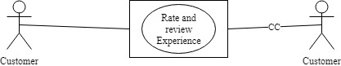

1. Choose Additional Accessories

|  |  |
| --- | --- |
| Use Case Name | Choose additional accessories |
| Scope | Under Design |
| Level | Sub Function |
| Primary Actor | Customer |
| Stakeholders and Interest | Professor, Customer |
| Preconditions | Customer needs to select a vehicle |
| Success Guarantee | List of Accessories are displayed and selected |
| Main Success Scenario | 1.Customer searches for additional accessories  2.Customer selects additional accessories |
| Extensions | Scenario 1:  1a) Customer refreshes Page |
| Special Requirements | Response time should be within seconds |
| Technology and Data Variations List | Browser, Database |
| Frequency of Occurrence | Could be nearly continuous |
| Miscellaneous | NA |

Use Case Diagram: Choose additional accessories

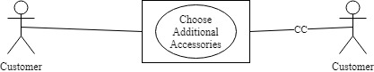

1. Pick up and Drop off Location

|  |  |
| --- | --- |
| Use Case Name | Select Pick up and Drop off location |
| Scope | Under Design |
| Level | Sub Function |
| Primary Actor | Customer |
| Stakeholders and Interest | Professor, Customer |
| Preconditions | Customer should have selected vehicle |
| Success Guarantee | Selects Customers Pick up and Drop off location |
| Main Success Scenario | 1.Customer visits the website  2.Customer select pick up and Drop off location |
| Extensions | Scenario 1:  1a) Customer Re-select pick up and drop off location |
| Special Requirements | Response time should be within seconds |
| Technology and Data Variations List | Browser, Database |
| Frequency of Occurrence | could be nearly continuous |
| Miscellaneous | NA |

Use Case Diagram: Pick up and Drop off location

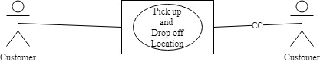

1. Access to Reports

|  |  |
| --- | --- |
| Use Case Name | Access to Reports |
| Scope | Under Design |
| Level | Sub Function |
| Primary Actor | Administrator |
| Stakeholders and Interest | Professor, Administrator |
| Preconditions | Application should be up and running |
| Success Guarantee | Reports are displayed |
| Main Success Scenario | 1.Administrator visits the website  2.Administrator selects the type of report  3.The Reports are displayed |
| Extensions | Scenario 1:  1a) Administrator refreshes Page  2a) Administrator Re-selects the type of reports |
| Special Requirements | Response time should be within seconds |
| Technology and Data Variations List | Browser, Database |
| Frequency of Occurrence | could be nearly continuous |
| Miscellaneous | NA |

Use Case Diagram: Access to Reports

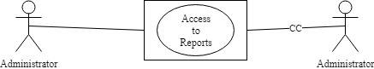

1. View Special Rates

|  |  |
| --- | --- |
| Use Case Name | View Special rates |
| Scope | Under Design |
| Level | Sub Function |
| Primary Actor | Customers |
| Stakeholders and Interest | Professor, Customer |
| Preconditions | Application should be up and running |
| Success Guarantee | All the special rates are displayed |
| Main Success Scenario | 1.Customer visits the website  2.Customer views special rates |
| Extensions | Scenario 1:  1a) Customer refreshes Page |
| Special Requirements | Response time should be within seconds |
| Technology and Data Variations List | Browser, Database |
| Frequency of Occurrence | 4 hits per second |
| Miscellaneous | NA |

Use Case Diagram: View special rates

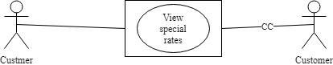

1. Manage Memberships

|  |  |
| --- | --- |
| Use Case Name | Manage Memberships |
| Scope | Under Design |
| Level | Sub Function |
| Primary Actor | Administrator, Customer |
| Stakeholders and Interest | Professor, Customer |
| Preconditions | Application should be up and running |
| Success Guarantee | Administrator assigns Customers with Memberships |
| Main Success Scenario | 1.Admin visits the website  2.Admin selects Customer to assign membership  3. Customers are assigned Membership |
| Extensions | Scenario 1:  1a) Administrator refreshes Page  2a) Administrator reassigns memberships |
| Special Requirements | Response time should be within seconds |
| Technology and Data Variations List | Browser, Database |
| Frequency of Occurrence | could be nearly continuous |
| Miscellaneous | NA |

Use Case Diagram: Manage Memberships



1. Access to Driving Records

|  |  |
| --- | --- |
| Use Case Name | Access to Driving Records |
| Scope | Under Design |
| Level | Sub Function |
| Primary Actor | Administrator |
| Stakeholders and Interest | Professor, Customer |
| Preconditions | Customer should have booked a vehicle |
| Success Guarantee | Driver’s Previous Records are displayed |
| Main Success Scenario | 1.Administrator visits the website  2.Administrator access the Driver’s Records  3.Adminitrattor allows customer to book the vehicle |
| Extensions | Scenario 1:  1a) If there are any red flags in the in driver’s records, the booking is cancelled |
| Special Requirements | Response time should be within seconds |
| Technology and Data Variations List | Browser, Database |
| Frequency of Occurrence | could be nearly continuous |
| Miscellaneous | NA |

Use Case Diagram: Access Driver’s previous Records

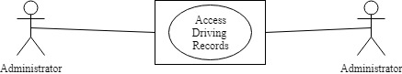

1. Redeem Reward Points

|  |  |
| --- | --- |
| Use Case Name | Redeem Rewards Points |
| Scope | Under Design |
| Level | Sub Function |
| Primary Actor | Customers |
| Stakeholders and Interest | Professor, Customer |
| Preconditions | Customer must be logged into the system |
| Success Guarantee | Customers Reward Points are Redeemed |
| Main Success Scenario | 1.Customer selects redeem reward points  2.Customer Redeems Reward Points for merchandize  3.The Rewards points are deducted from account |
| Extensions | Scenario 1:  1a) Customer refreshes Page  3a) If Redeeming points is unsuccessful, points are returned to the account |
| Special Requirements | Response time should be within seconds |
| Technology and Data Variations List | Browser, Database |
| Frequency of Occurrence | could be nearly continuous |
| Miscellaneous | NA |

Use Case Diagram: Redeem reward Points

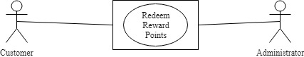

1. Navigate Pick Up Location

|  |  |
| --- | --- |
| Use Case Name | Navigate Pick Up Location |
| Scope | Under Design |
| Level | Sub Function |
| Primary Actor | Customers |
| Stakeholders and Interest | Professor, Customer |
| Preconditions | Customer has completed the car booking |
| Success Guarantee | Customer has navigated his location using map |
| Main Success Scenario | 1.Customer Navigates Pick Up Location using maps |
| Extensions | Scenario 1:  1a) Customer reloads the maps |
| Special Requirements | Response time should be within seconds |
| Technology and Data Variations List | Browser, Database |
| Frequency of Occurrence | could be nearly continuous |
| Miscellaneous | NA |

Use Case Diagram: Navigate Pick Up location

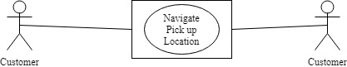

1. Access to customer benefits

|  |  |
| --- | --- |
| Use Case Name | Access to customer benefits |
| Scope | Under Design |
| Level | Sub Function |
| Primary Actor | Customers |
| Stakeholders and Interest | Professor, Customer |
| Preconditions | Customer should be registered and logged in |
| Success Guarantee | Customer gets access to customer benefits |
| Main Success Scenario | 1.Customer visits the website  2.Customer selects multiple customer benefits |
| Extensions | Scenario 1:  1a) Customer refreshes Page |
| Special Requirements | Response time should be within seconds |
| Technology and Data Variations List | Browser, Database |
| Frequency of Occurrence | could be nearly continuous |
| Miscellaneous | NA |

Use Case Diagram: Access to customer benefits

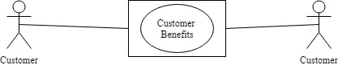

1. Provide Promotions, Membership rewards points, Family benefits

|  |  |
| --- | --- |
| Use Case Name | Provide promotions, membership rewards points, family benefits |
| Scope | Under Design |
| Level | Sub Function |
| Primary Actor | Administrator, Customer |
| Stakeholders and Interest | Professor, Customer |
| Preconditions | Customer should be registered |
| Success Guarantee | Administrator provides promotions, membership rewards points, family benefits |
| Main Success Scenario | 1.Administrator visits the website  2.Aministrator checks for membership  3.Administrator Provides promotions, membership rewards points, family benefits to Customers |
| Extensions | Scenario 1:  1a) Administrator refreshes Page  2a) If customer is not a member then page redirects to registration |
| Special Requirements | Response time should be within seconds |
| Technology and Data Variations List | Browser, Database |
| Frequency of Occurrence | could be nearly continuous |
| Miscellaneous | NA |

Use Case Diagram: Provide promotions, membership rewards points, family benefits

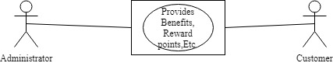

1. Administrator Should Provide Proper Encryption

|  |  |
| --- | --- |
| Use Case Name | Encryption to Customers Credentials |
| Scope | Under Design |
| Level | Sub Function |
| Primary Actor | Administrator, Customer |
| Stakeholders and Interest | Professor, Customer |
| Preconditions | Application should be up and running |
| Success Guarantee | Customers credentials are encrypted |
| Main Success Scenario | 1.Administrator visits the website  2.Administrator encrypts Customer credentials |
| Extensions | Scenario 1:  1a) Administrator refreshes Page |
| Special Requirements | Response time should be within seconds |
| Technology and Data Variations List | Browser, Database |
| Frequency of Occurrence | could be nearly continuous |
| Miscellaneous | NA |

Use Case Diagram: Encrypt Customer Credentials

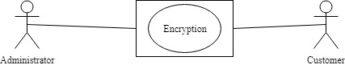

1. Choose calendar day

|  |  |
| --- | --- |
| Use Case Name | Choose Calendar Day or 24-hour day |
| Scope | Under Design |
| Level | Sub Function |
| Primary Actor | Customer |
| Stakeholders and Interest | Professor, Customer |
| Preconditions | Application should be up and running |
| Success Guarantee | Customers selects a Calendar day |
| Main Success Scenario | 1.Customer visits the website  2.Customer selects a calendar day |
| Extensions | Scenario 1:  1a) Customer refreshes Page |
| Special Requirements | Response time should be within seconds |
| Technology and Data Variations List | Browser, Database |
| Frequency of Occurrence | could be nearly continuous |
| Miscellaneous | NA |

Use Case Diagram: Calendar Day or 24 hour day

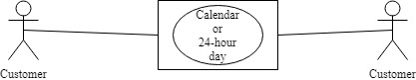

1. Customize Payments

|  |  |
| --- | --- |
| Use Case Name | Customize Payments |
| Scope | Under Design |
| Level | Sub Function |
| Primary Actor | Customer |
| Stakeholders and Interest | Professor, Customer |
| Preconditions | Customer should select a Vehicle |
| Success Guarantee | Customers customizes payments |
| Main Success Scenario | 1.Customer selects onetime payment or instalments  2.Booking is confirmed |
| Extensions | Scenario 1:  2a) Customer re-selects payments |
| Special Requirements | Response time should be within seconds |
| Technology and Data Variations List | Browser, Database |
| Frequency of Occurrence | could be nearly continuous |
| Miscellaneous | NA |

Use Case Diagram: Customize payments

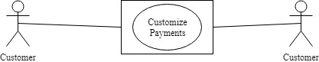

1. Payment through PayPal

|  |  |
| --- | --- |
| Use Case Name | Payment through PayPal |
| Scope | Under Design |
| Level | Sub Function |
| Primary Actor | Customer |
| Stakeholders and Interest | Professor, Customer |
| Preconditions | Customer has selected a vehicle |
| Success Guarantee | Customers pays through PayPal |
| Main Success Scenario | 1.Customer selects PayPal as payment option  2.Customer pays using PayPal  3. PayPal will authorize payment |
| Extensions | Scenario 1:  1a) Customer refreshes Page  2a) Customer selects other payment method |
| Special Requirements | Response time should be within seconds |
| Technology and Data Variations List | Browser, Database |
| Frequency of Occurrence | could be nearly continuous |
| Miscellaneous | NA |

Use Case Diagram: Payment using PayPal

